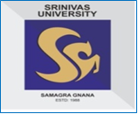
SRINIVASUNIVERSITY
SrinivasNagar, Mukka–574146, Mangalore, Phone: 0824-2441022
(State Private University Established by Karnataka Govt. ACT No.42 of 2013, recognized by UGC, New Delhi & Member of Association of Indian Universities, New Delhi)
Web:www.srinivasuniversity.edu.in,
Email:admission@srinivasuniversity.edu.in

Administrative Office: GHS Road, Mangalore-01, Phone: 0824-2425966, 2412382

INSTITUTE OFMANAGEMENT & COMMERCE
Bachelor of Business Administration (BBA-HOSPITAL ADMINISTRATION)
ADMISSION OPEN
Duration: 4 years, eight semesters. (As per NEP guidelines)
Eligibility: Passin10+2/12th Standard with minimum 50% marks.
Admission needs valid score in SUAT.
The classes will be held at Institute of Management and Commerce
City Campus, Pandeshwar, Mangalore–575001.Phone: 0824-2441022, 2422851

About BBA – (HOSPITAL ADMINISTRATION) :
Bachelor of Business Administration – Hospital Administration (BBA-HA) program is a four-year graduate programme. It focuses on the healthcare industry. The program trains students in areas such as – operations, HR management, marketing, finance management and insurance – related to the healthcare industry. Healthcare and hospital management professionals are hired by healthcare institutes to carry out the above mentioned managerial tasks! Basically, BBA in Hospital Administration course trains students and turns them into management professionals who are capable of managing and handling various tasks in a healthcare institute.
On the basis of marks scored at 10 + 2 / 12th Standard with minimum 40% marks. Admission needs valid score in SUAT. Our training program focuses on equipping each individual with conceptual, analytical, communication skills and healthy attitudes to ensure excellent performance and committed service to the society at large

Special Features of the Program:
- Classes will be held between 9.00 am to 2.00 pm with half an hour break during week days.
- E-Study material will be provided from the college for every subject according to the syllabus.
- Hospital Management oriented syllabus with special focus on experimental learning & skill enhancement.
- Hands on live projects in each semester.
- Focus on experiential learning.
- Innovations in examination system with opportunity for personal seeing of evaluated papers.
- 50% weight age of marks on continuous evaluation and 50% weight age on semester end exam.
- Make-up exams in every semester to avoid year loss.
- Opportunity to take Specialization.
- Placement support and Internship projects for every student.
- Opportunity to visit various Hospital institute and Health care industries.
- Separate Hostel &Transport facility for boys & Girls.
- Further Opportunity to do MBA, M.Com. M.Phil., &Ph.D. Programmes.
- Earn while Learn Opportunity in Retail/BPO/Software companies during evening time.

Career Opportunities:

BBA in Hospital Administration is an opens door to lucrative careers in four areas: providers of medical services, suppliers of equipment and pharmaceuticals, insurance companies and administration of healthcare facilities. Each area includes hundreds of job opportunities that range from hospital administration to formulating policies for governmental and health departments. Hospital Administrator Pharmaceutical Project Manager, Policy Analyst or Researcher, Health Services Managers and Administrators, Medical Entrepreneurship.

Programme Structure:

S. No. | Semester 1 | Credits | Marks
1 | Business Accounting I | 4 | 100
2 | Hospital & Health System | 4 | 100
3 | Fundamentals of Management | 4 | 100
4 | Personality Development/ Quantities’ Techniques 1/ Cyber Security & Ethics | 4 | 100
5 | Communicative English II | 4 | 100
6 | Language II | 4 | 100
7 | Digital Fluency & Employability Skill Enhancement Project – ICA | 2 | 50
8 | Health & Wellness - Diet & Nutrition & Emotional Learning | 2 | 50
 |  | 28 | 700
S.No. | Semester 2 | Credits | Marks
1 | Business Accounting II | 4 | 100
2 | Hospital Planning | 4 | 100
3 | Human Resources Management | 4 | 100
4 | Stock markets / Quantities’ Techniques II/ Tourism & Travel management Journalism & Mass Communication | 4 | 100
5 | Communicative English II | 4 | 100
6 | Language II | 4 | 100
7 | Environmental Studies & SDGS’S | 2 | 50
8 | NSS /R&R(S&G) /Cultural/ Physical Education/Sports | 2 | 50
 |  | 28 | 700

S. No. | Semester 3 | Credits | Marks
1 | Financial Management | 4 | 100
2 | Corporate Accounting | 4 | 100
3 | Hospital Environment and Eco policy | 4 | 100
4 | Retail Management / Event management marketing | 4 | 100
5 | Language – I | 4 | 100
6 | Language – II | 3 | 100
7 | Business oriented computer applications | 3 | 50
8 | Business Etiquette & Corporate Grooming | 2 | 50
9 | Sports/NCC/NSS/ Cultural | - | -
 |  | 28 | 700

S. No. | Semester 4 | Credits | Marks
1 | Operation Research | 4 | 100
2 | Organizational Behavior | 4 | 100
3 | Hospital Operation Management | 4 | 100
4 | Business Leadership Skills/Personal Wealth Management | 4 | 100
5 | Language – I (Professional Communication) | 4 | 100
6 | Language – II | 4 | 100
7 | Constitution of India | 2 | 50
8 | Cyber Security | 2 | 50
9 | Sports/NCC/NSS/ Cultural | - | -
 |  | 28 | 700

S. No. | Semester 5 | Credits | Marks
1 | Cost Accounting | 4 | 100
2 | International Business | 4 | 100
3 | Hospital Material Record Management & Hospital Information system | 4 | 100
4 | Entrepreneurship & Startup Management | 4 | 100
5 | Goods and Service Tax | 4 | 100
6 | Information Technology for Managers | 4 | 100
7 | Right to get Information (RTI) | 2 | 50
8 | Ethics & Self-Awareness | 2 | 50
9 | Sports/NCC/NSS/ Cultural | - | -
 |  | 28 | 700
S. No. | Semester 6 | Credits | Marks
1 | Research Projects/Internship with Viva – voce | 28 | 700
 |  | 28 | 700

*VI semester comprises industry internship study as part of immersive learning in curriculum.

S. No. | Semester 7 | Credits | Marks
1 | Business Ethics & Corporate Governance | 4 | 100
2 | Applied research and statistics | 4 | 100
3 | Elective –I  Hospital Support and Utility Services & Legal aspects Elective- II  Hospital Hazards and Disaster Management | 4 | 100
4 | Company Law | 4 | 100
5 | Research Methodology | 4 | 100
6 | Intellectual Property Rights | 4 | 100
7 | Application of Statistical Software (Any one Statistical Software) | 2 | 50
8 | Sports/NCC/NSS/ Cultural | 2 | 50
 |  | 28 | 700
S. No. | Semester 8 | Credits | Marks
1 | Strategic Management | 4 | 100
2 | Project Management | 4 | 100
3 | Operations Research and Quantitative Techniques | 4 | 100
4 | Business Laws | 4 | 100
5 | Digital marketing | 4 | 100
6 | Research Methodology-II | 4 | 100
7 | Application of Statistical Software (Any one Statistical Software-SPSS) | 2 | 50
8 | Management Information System | 2 | 50
9 | Sports/NCC/NSS/ Cultural | - | -
 |  | 28 | 700

EXTRA CURRICUALR ACTIVITY 2021- 2022

- DEPARTMENTAL EXTENTIONAL ACTIVITY - 2021-2022

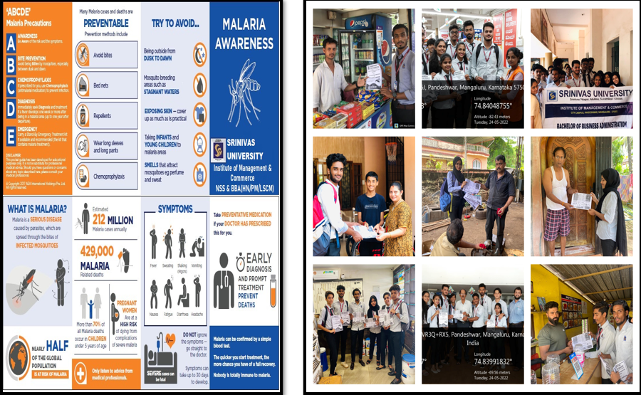

- SOCIAL RESPONSIBILITY INITIATIVES

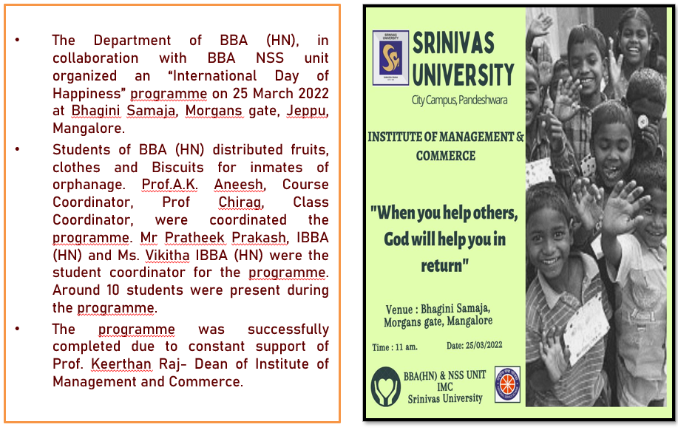

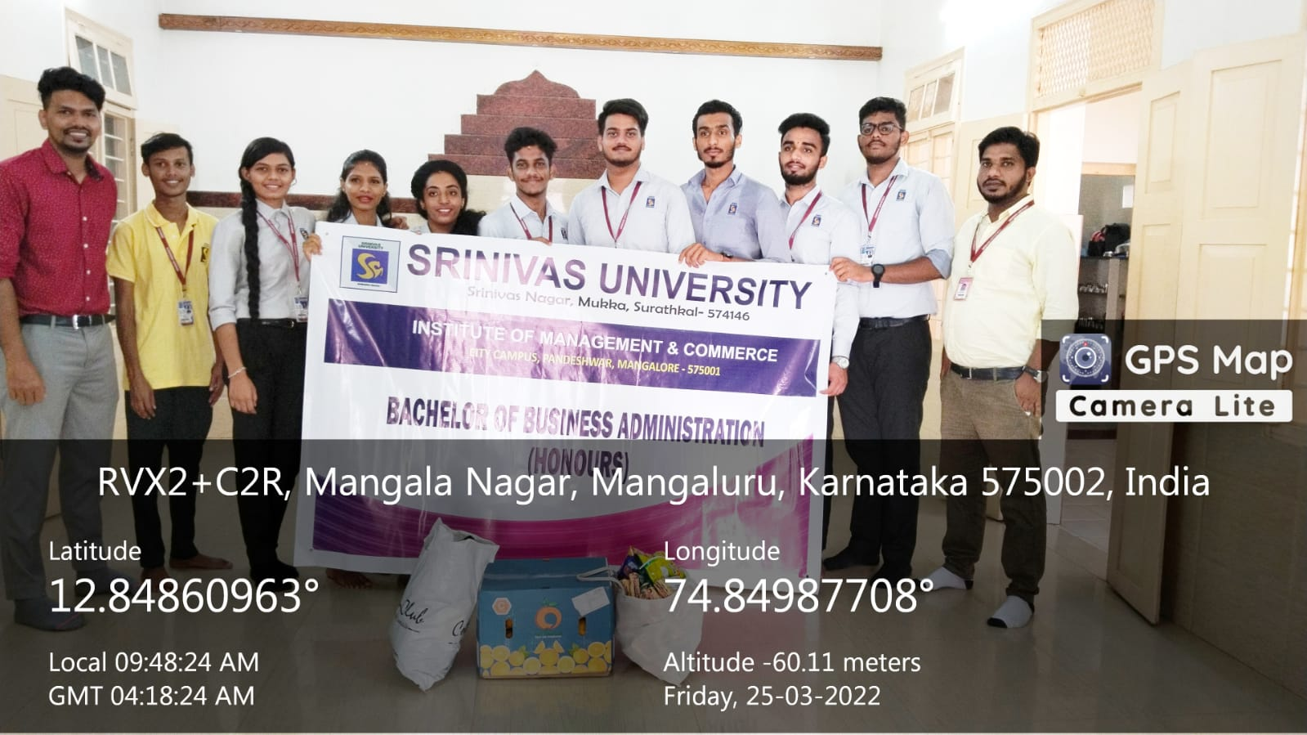

JOIN ABOVE INNOVATIVE BBA(HN) PROGRAMME WITH INDUSTRY RELEVANCE AND JOBORIENTED SYLLABUS TO RE-DEFINE YOUR CAREER ALTITUDE!!!
Institute ofManagement & Commerce
CREATINGINNOVATORS

SRINIVASUNIVERSITY
Educating the Next Generation

